Balasmiq Account screenshot
-Take and submit a screenshot showing that you created an account with Balsamiq

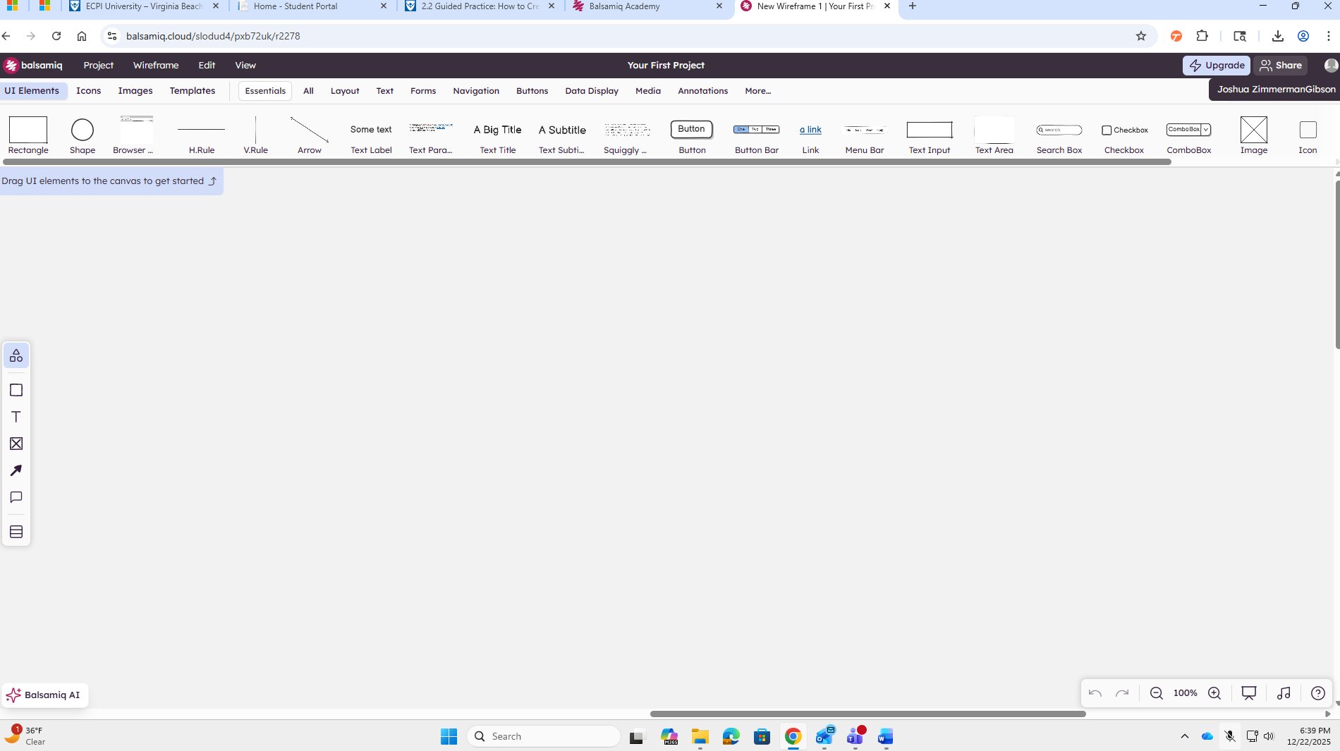
the last frame of the step-by-step tutorial
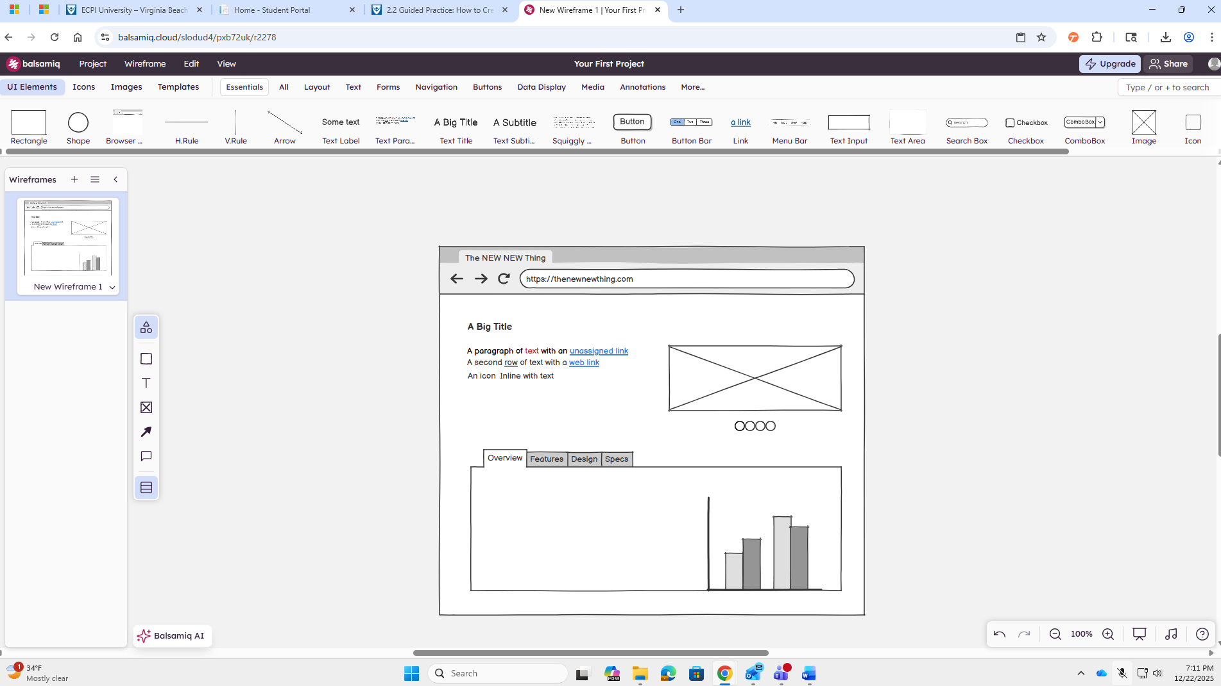
Wireframe
Includes 10 - 15 requirements, a main page, and at least 3 subpages.
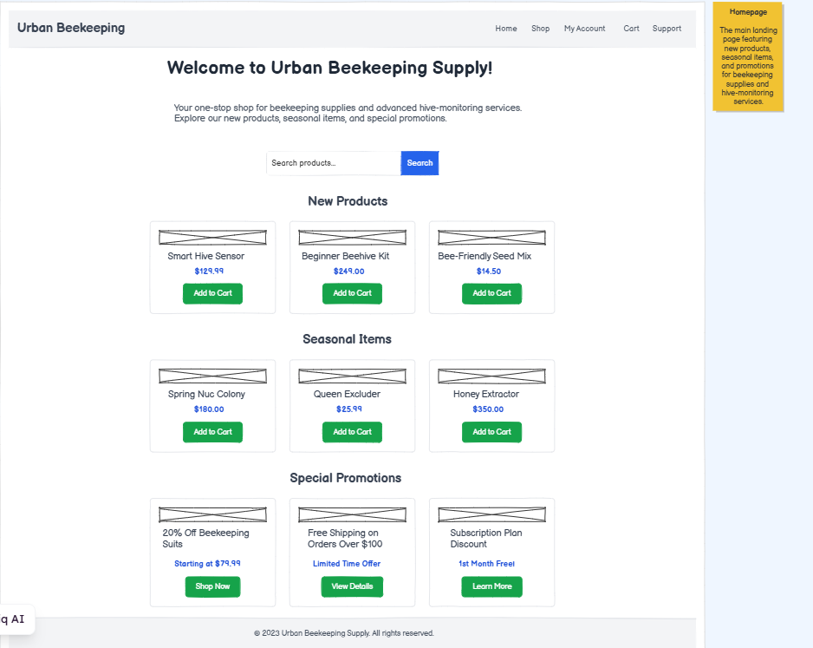
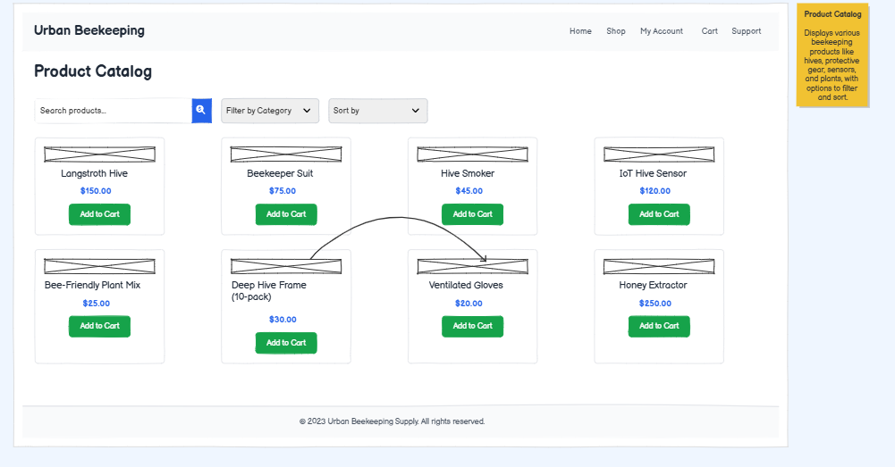
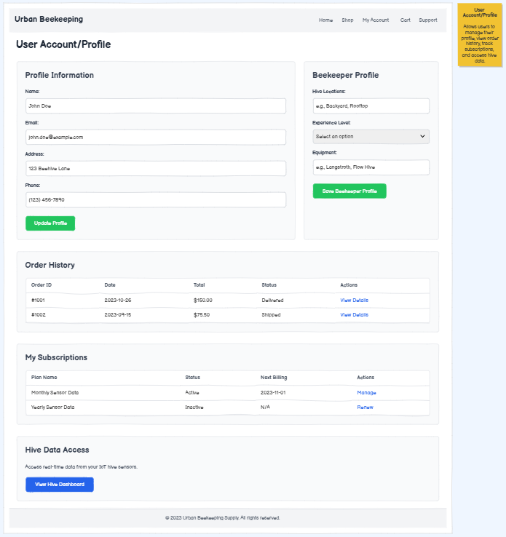
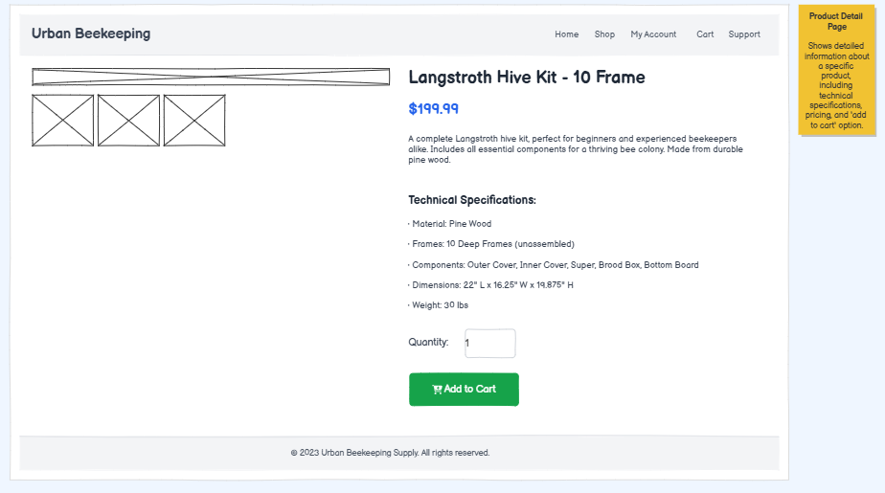
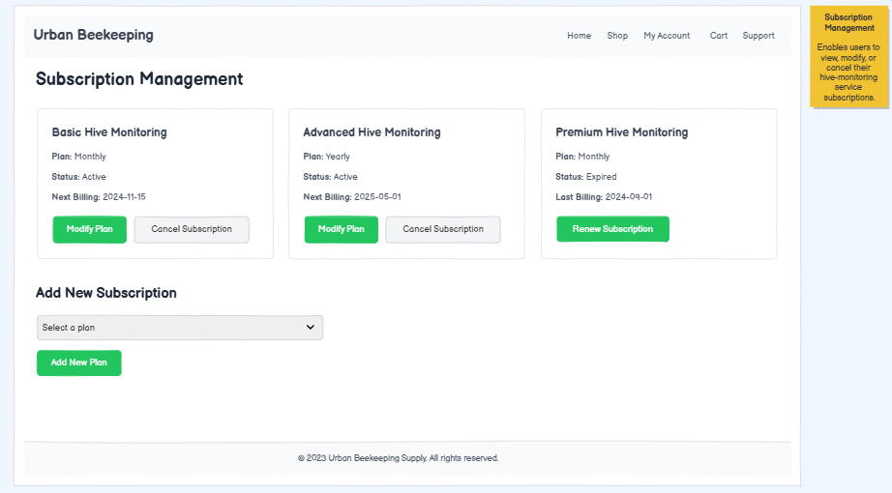
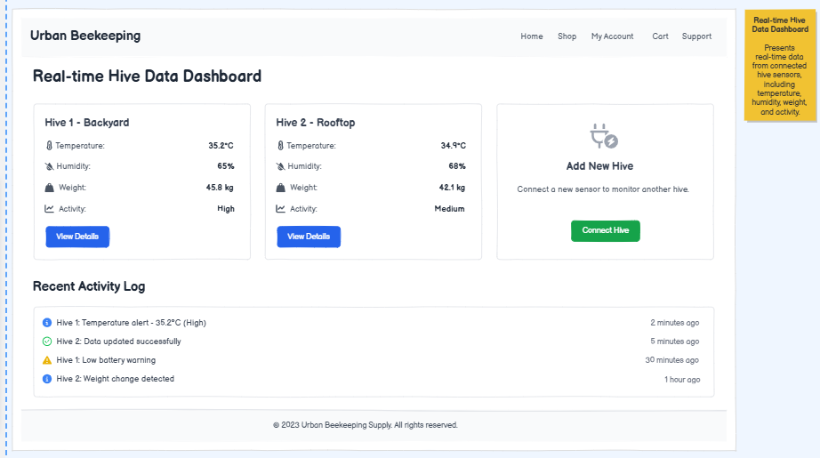
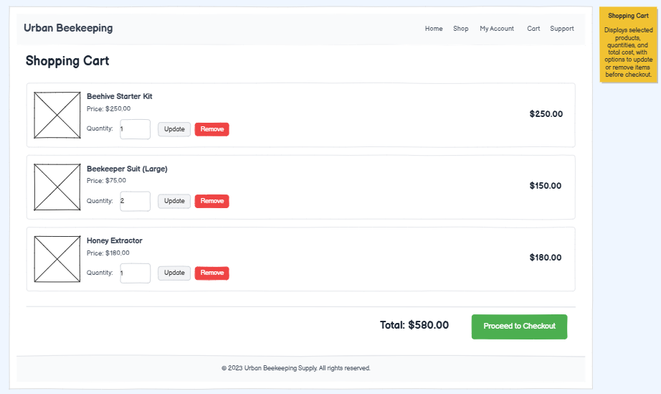
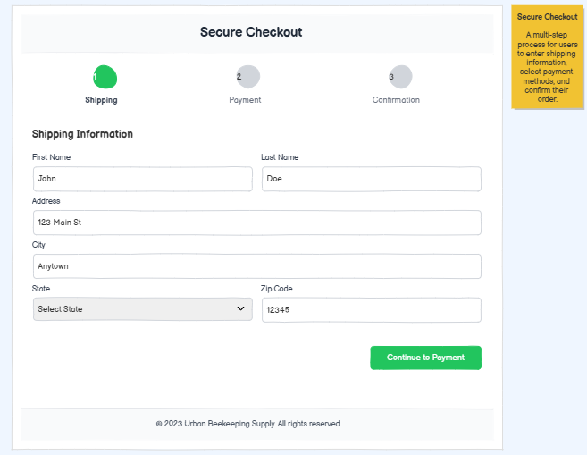

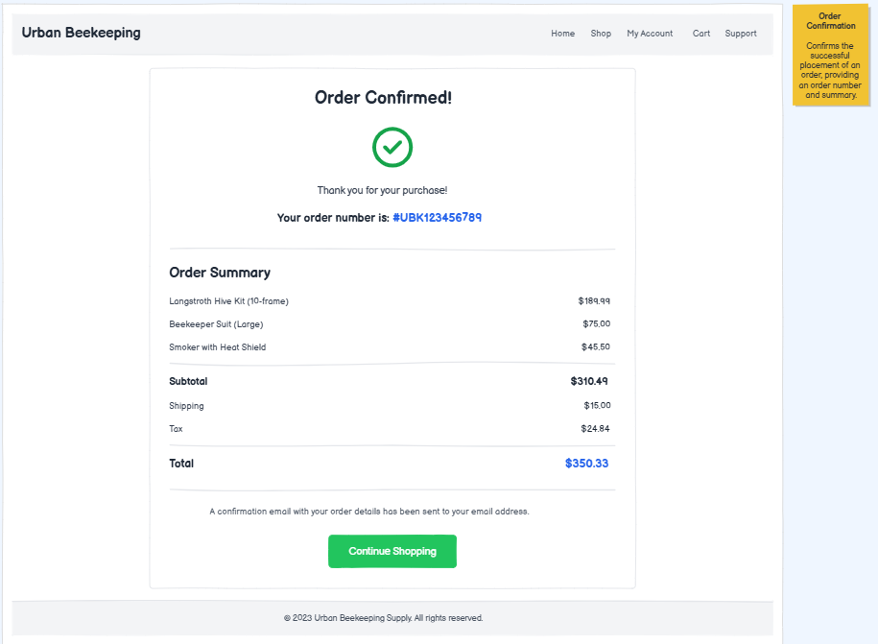
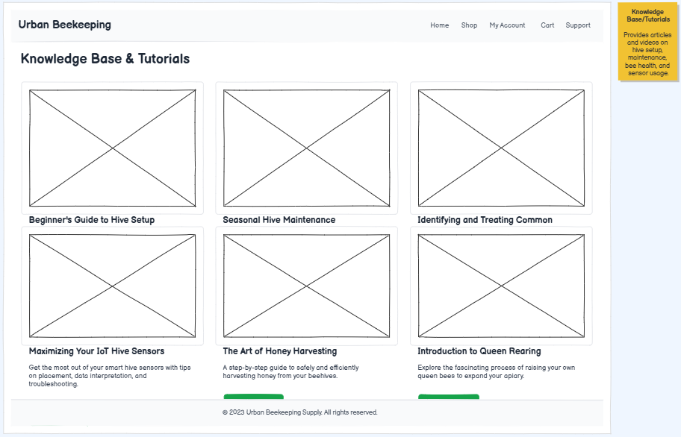
Functional Requirements
- User account creation and beekeeper profile setup: Users can register and specify hive locations, experience level, and equipment owned.
- Product catalog with technical specifications: Items include hives, frames, suits, smokers, sensors, and bee-friendly plants.
- Subscription management for hive-monitoring services: Users can subscribe to monthly or yearly sensor data plans.
- Integration with IoT hive sensors: Users can view real-time hive data (temperature, humidity, hive weight, activity).
- Shopping cart and secure checkout: Standard add/remove/update functionality with multi-step checkout.
- Electronic payment processing: Supports credit cards, PayPal, and recurring billing for subscriptions.
- Automated shipping calculation for bulky items: Hives and frames require special shipping rules.
- Inventory tracking for seasonal products: Bee colonies and certain plants are only available during specific months.
- Admin dashboard for product and sensor management: Staff can update product listings and manage sensor activation codes.
- Knowledge base and tutorial integration: Articles and videos on hive setup, maintenance, and bee health.

